Reflection(week 2):-

In week 2 lab, we are given with csv file so firstly we need to download the file and perform the MongoDB operations using MongoDB compass as given in lab tutorial. After that we connect MongoDB server and created peopledb database in MongoDB Compass. Then we import the given csv file to peopled database. We have learn about Importing a document, Inserting a document, Deleting a document and Aggerate pipe line as well. At last, also learn about Query to find avg,min,max age and avg min max salary of people and many more.

Lab tasks

* Write MongoDB queries for the following using either command shell:

1. Repeat the same process to search Education for Master and. Find the average, minimum, max-age, and average minimum-maximum Salary of the people group by Marital status.

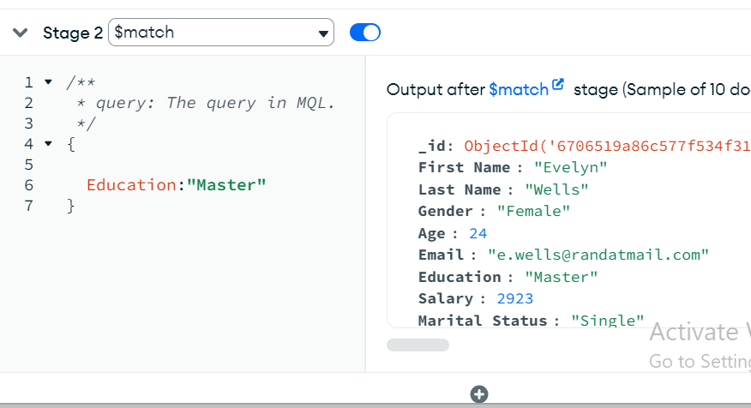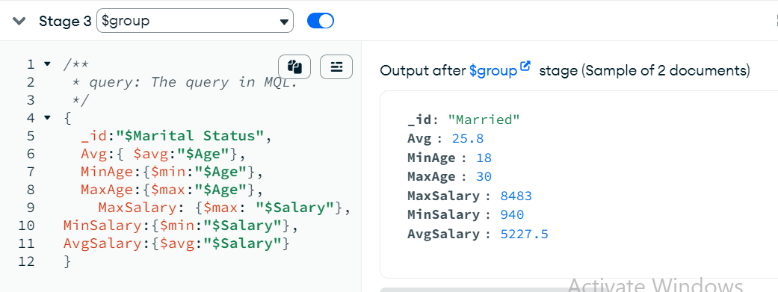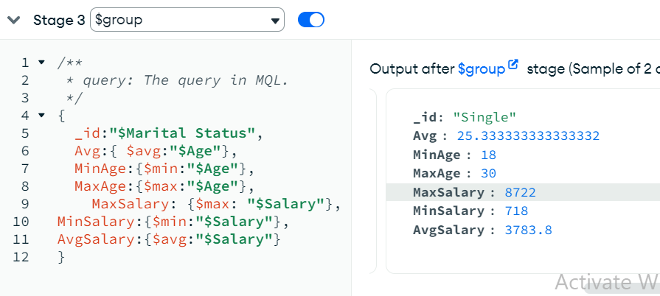

2. find minimum, the maximum average salary of each group of female.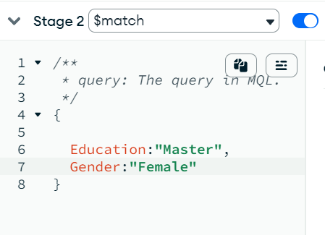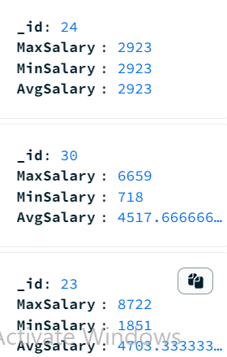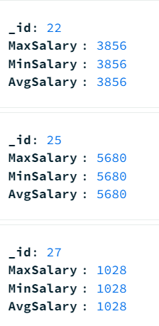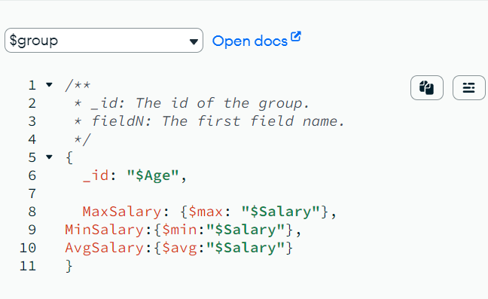

3. Find the minimum and maximum average salary of each age group of males.

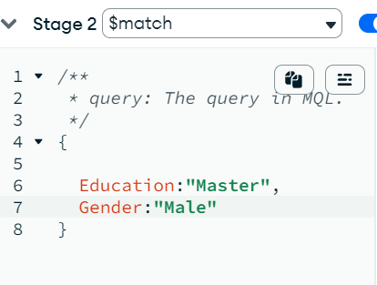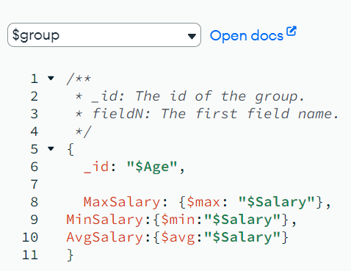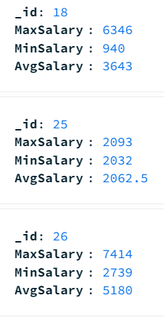

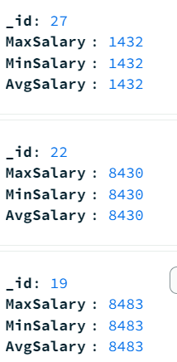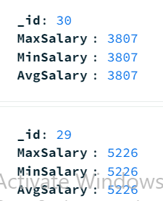

4. Count married and unmarried females and males.

